|  |  |
| --- | --- |
| **Name** |  |
| **Reg. No** |  |

**EXPERIMENT # 05**

**Analysis of system containing Regulating Transformer**

**Objective:**

To learn the importance of voltage regulation by tap changing transformer on PWS.

**Theory:**

Almost all transformers incorporate some means of adjusting their voltage ratio, by adding or removing tapping turns. This adjustment may be made by an on-load tap-changer, or by means of an off-circuit tap-changer, or by the selection of bolted link positions with the transformer disconnected and grounded.

**Off Circuit Tap Changer**

The off-circuit tap-changer is of rather simple design, giving connection to a selected tap in the winding. As the name says it is designed only to be operated only when the transformer is de-energized. The contact pressure may occur to be retained by some kind of spring arrangement and then some vibration is possible.

**On Load Tap Changer (OLTC)**

The on-load tap-changer has to provide uninterrupted current flow during the transition operation from one tap to the other. The current flow must be maintained uninterrupted without partial short-circuiting of the tapped winding.

**Analysis of system Containing Tap Changing Transformer:**

The network is given as for which calculation is to be performed.

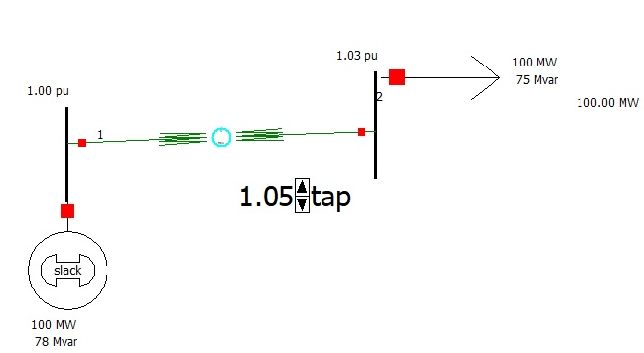

Figure 1: Tap changing transformer circuit

**Regulating Transformer Hand Calculation:**

Evaluate the voltage at bus 2 for various tap changing transformation ratio as given below

For tap changing transformation ratio 1:1

For tap changing transformation ratio .95:1

For tap changing transformation ratio 1.05:1

For tap changing transformation ratio 1:1.05

For tap changing transformation ratio 1:.95

**Using PWS:**

Draw online diagram at PWS

In edit mode go to draw $→$ Field $→$ Transformation Field

**Manual Control:**

Now click on transformer on which you want to have the tap changer. A dialogue box will open. In type of field option select off nominal Tap Ratio (PWS connects the tap changer on the form side of transformer) e.g. if a transformer is connected from bus 1 to bus 2, PWS will attach tap on winding which is connected to bus 1 and if transformer is connected from bus 2 to 1, PWS will attach tap on winding which is connected to bus 2.

Corroborate your theoretical calculation of Y bus and V2 with the PWS results for different tap changing transformer ratios.

**Automatic Control:**

Double click on transformer in transformer control check automatic control enabled and in change automatic control option select voltage regulation as automatic control type. When transformer tap control is automatic control then tap changing symbol is drawn on tap changing side of transformer.

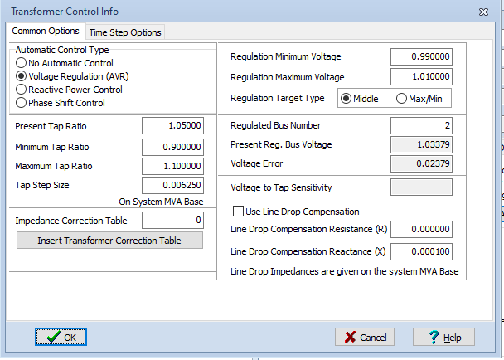

Figure 2: Automatic Control of Transformer

Assignment:

Perform above calculation using newton Raphson method.

* ***Calculate Y bus for each tap changing value.***
* ***Make a system of 9 bus system in such a way that taps are attached to higher voltage level of all transformer and are regulating the voltages of buses connected to them.***
* ***Observe system with changing phase angle of transformer.***